

**LAB FILE**

**Web Programming with Python and JavaScript Lab**

**(SEC 035)**

**SUBMITTED BY:**

**ADEELA AZEEZ**

**SUBMIITED TO:**

**DR. TANVI CHAWLA**

**ROLL NUMBER: 2301010282**

**COURSE: BTECH CSE CORE**

**SECTION: E**

**School of Engineering & Technology**

**K. R. MANGALAM UNIVERSITY**

**Sohna, Haryana 122103, India**

**EXPERIMENT 2.1**

**JAVASCRIPT BASIC PROGRAMS**

***Experiment 2.1.1: Odd and Even Number:***

**Code:**

function checkEvenOdd(number)

{

    if(number%2==0)

    {

        return "Even";

    }

    else{

        return "Odd";

    }

}

console.log(checkEvenOdd(7));

console.log(checkEvenOdd(10));

**Output:**

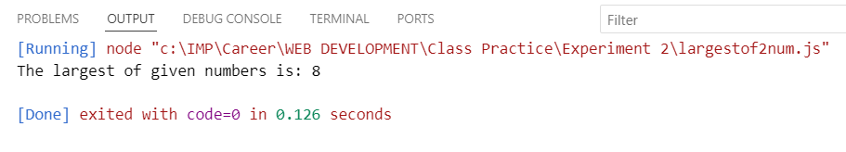

***Experiment 2.1.2: Factorial of a Number:***

**Code:**

function findFactorial(number)

{

    let fact=1;

    for(let i=1; i<=number; i++)

    {

        fact=fact*i;

    }

    return fact;

}

console.log(findFactorial(5));

console.log(findFactorial(6));

**Output:**

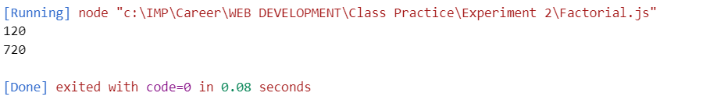

***Experiment 2.1.3: Prime Number:***

**Code:**

let n = 17;

let isPrime = true;

if (n <= 1) {

    isPrime = false;

} else {

    for (let i = 2; i * i <= n; i++) {

        if (n % i === 0) {

            isPrime = false;

            break;

        }

    }

}

console.log(isPrime ? `${n} is a prime number.` : `${n} is not a prime number.`);

**Output:**

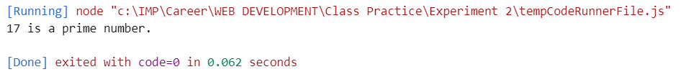

***Experiment 2.1.4: Largest of two numbers:***

**Code:**

function largest(a,b){

    if(a>b){

        return a;

    }

    else{

        return b;

    }

}

console.log(`The largest of given numbers is: `+largest(8,2))

**Output:**

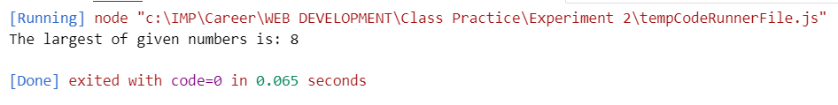

***Experiment 2.1.5: Sum of given array:***

**Code:**

const arr = [23, 34, 77, 99, 34];

let sum = 0;

for (let i = 0; i < arr.length; i++) {

sum += arr[i];

}

console.log(sum);

**Output:**

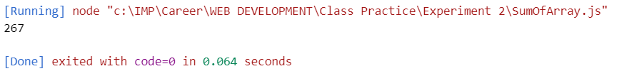

***Experiment 2.1.6: Swapping two numbers:***

**Code:**

let t;

let num1=20;

let num2=30;

console.log(`before swap num1= ${num1}`);

console.log(`before swap num2= ${num2}`);

t=num1;

num1=num2;

num2=t;

console.log(`after swap a= ${num1}`);

console.log(`after swap a= ${num2}`);

**Output:**

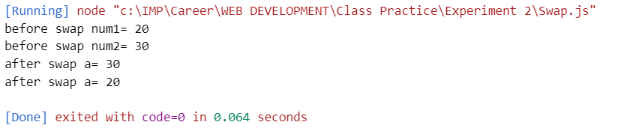

***Experiment 2.1.7: Table of a Number:***

**Code:**

function table(number)

{

    for (let i=1;i<=10; i++)

        {

            var result=i*number;

            console.log(`${number}*${i}=${result}`);

        } }

table(6);

**Output:**

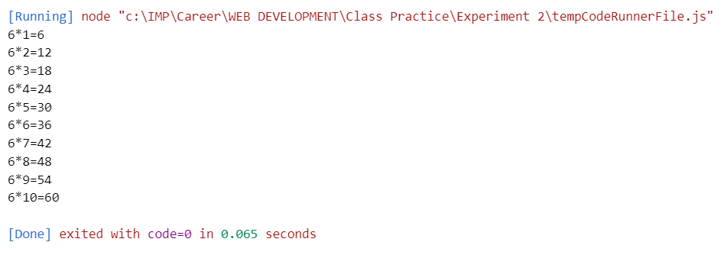

**EXPERIMENT 2.2**

**JAVASCRIPT OUTPUT PROGRAMS**

***Experiment 2.2.1: Using innerHTML:***

**Code:**

<!DOCTYPE html>

<html>

<body>

<h2>My First Web Page</h2>

<p>My First Paragraph.</p>

<p id="demo"></p>

<script>

document.getElementById("demo").innerHTML = 5 + 6;

</script>

</body>

</html>

**Output:**

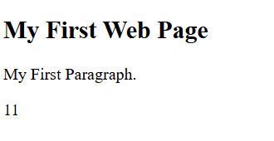

***Experiment 2.2.2: Using document.write()***

**Code:**

<!DOCTYPE html>

<html>

<body>

<h2>My First Web Page</h2>

<p>My first paragraph.</p>

<p>Never call document.write after the document has finished loading.

It will overwrite the whole document.</p>

<script>

document.write(5 + 6);

</script>

</body>

</html>

**Output:**

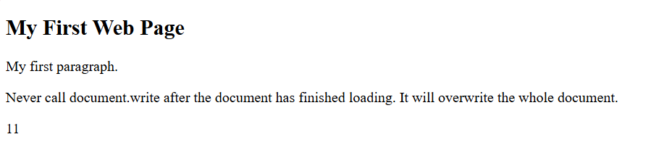

***Experiment 2.2.3: Using document.write() using Try it***

**Code:**

<!DOCTYPE html>

<html>

<body>

<h2>My First Web Page</h2>

<p>My first paragraph.</p>

<button type="button" onclick="document.write(5 + 6)">Try it</button>

</body>

</html>

**Output:**



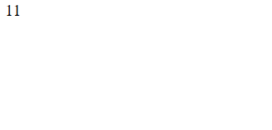

***Experiment 2.2.4: Using window.alert()***

**Code:**

<!DOCTYPE html>

<html>

<body>

<h1>My First Web Page</h1>

<p>My first paragraph.</p>

<script>

window.alert(5 + 6);

</script>

</body>

</html>

**Output:**

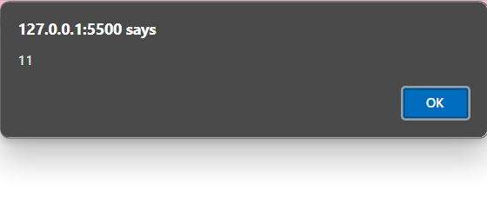



***Experiment 2.2.5: Using alert()***

**Code:**

<!DOCTYPE html>

<html>

<body>

<h1>My First Web Page</h1>

<p>My first paragraph.</p>

<script>

window.alert(5 + 6);

</script>

</body>

</html>

**Output:**





***Experiment 2.2.6: Using console.log()***

**Code:**

<html>

<head></head>

<body>

    <h1>Check the console for the message!</h1>

    <script>

        console.log("Hello, World!");

    </script>

</body>

</html>

**Output:**

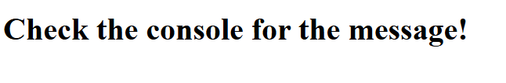

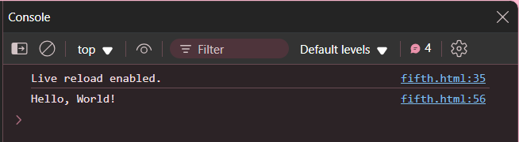

***Experiment 2.2.7: Using windows.print()***

**Code:**

<!DOCTYPE html>

<html>

<body>

<button onclick="window.print()">Print this page</button>

</body>

</html>

**Output:**



***Experiment 2.2.8: External JavaScript***

**Code:**

**HTML:**

<!DOCTYPE html>

<html>

<body>

<h2>Demo External JavaScript</h2>

<p id="demo">A Paragraph.</p>

<button type="button" onclick="myFunction()">Try it</button>

<p>This example links to "myScript.js".</p>

<p>(myFunction is stored in "myScript.js")</p>

<script src="seventh.js"></script>

</body>

</html>

**JAVASCRIPT**

function myFunction() {

document.getElementById("demo").innerHTML = "Paragraph changed.";

}

**Output:**

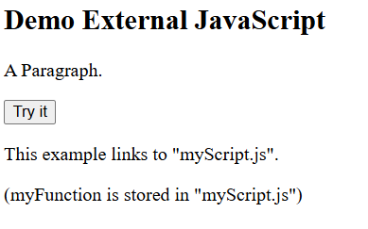 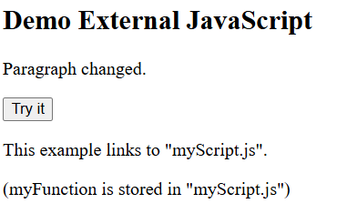

***Experiment 2.2.9: Displaying hidden HTML elements using JavaScript***

**Code:**

<!DOCTYPE html>

<html>

<body>

<h2>What Can JavaScript Do?</h2>

<p>JavaScript can show hidden HTML elements.</p>

<p id="demo" style="display:none">Hello JavaScript!</p>

<button type="button" onclick="document.getElementById('demo').style.display='block'">Click Me!</button>

</body>

</html>

**Output:**

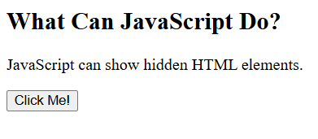  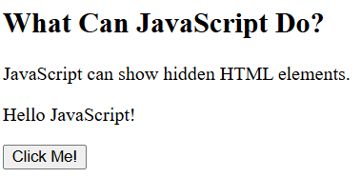

***Experiment 2.2.10: Printing an array***

**Code:**

**HTML and CSS:**

<!DOCTYPE html>

<html lang="en">

<head>

    <meta charset="UTF-8">

    <meta name="viewport" content="width=device-width, initial-scale=1.0">

    <title>Document</title>

    <style>

        body{

            padding:20px;

        }

        .container{

            height: 200px;

            width: 300px;

            padding: 5px;

            border: solid black 2px;

            background-color: aquamarine;

        }

        p{

            font-size: 30px;

        }

        button{

            font-size:20px;

            padding: 5px;

            font-family: 'Times New Roman', Times, serif;

        }

    </style>

    <script src="tenth.js"></script>

</head>

<body>

    <div class="container">

        <button type="button" onclick="myFunction()">Click to print array</button>

    <p id="demo"></p>

        </div>

</body>

</html>

**JavaScript:**

function myFunction() {

let numbers = [10, 20, 30, 40, 50];

document.getElementById("demo").innerHTML = numbers.join(" , ");

}

**Output:**

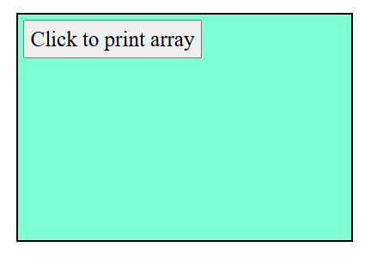 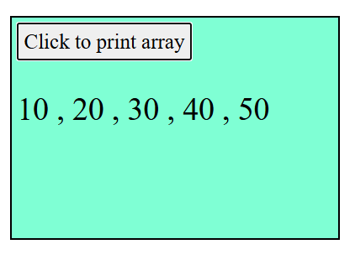

**EXPERIMENT 2.3**

***Experiment 2.3.1:*** ***Implement a js function to change the background of a button on hover***

**Code:**

 <!DOCTYPE html>

 <html lang="en">

 <head>

    <meta charset="UTF-8">

    <meta name="viewport" content="width=device-width, initial-scale=1.0">

    <title>Document</title>

 </head>

 <body>

    <button id="hoverButton">MyButton</button>

    <br>

    <span>HOVER OVER</span>

    <script>

        const button = document.getElementById("hoverButton");

        button.addEventListener("mouseover", function () {

        button.style.backgroundColor = "yellow";

    });

    button.addEventListener("mouseout", function () {

        button.style.backgroundColor = "gray";

    });

    </script>

 </body>

 </html>

**Output:**

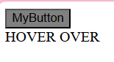

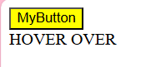

***Experiment 2.3.2: Create a js countdown timer that triggers an event when the timer reaches zero***

**Code:**

<!DOCTYPE html>

 <html lang="en">

 <head>

    <meta charset="UTF-8">

    <meta name="viewport" content="width=device-width, initial-scale=1.0">

    <title>Document</title>

 </head>

 <body>

    <div id="countdownDisplay" style="font-size: 24px; font-weight: bold;"></div>

    <script>

        function startCountdown(durationInSeconds, displayElement) {

        let timeLeft = durationInSeconds;

        const countdownInterval = setInterval(function () {

        let minutes = Math.floor(timeLeft / 60);

        let seconds = timeLeft % 60;

        displayElement.textContent = `${minutes}:${seconds < 10 ? '0' : ''}${seconds}`;

        if (timeLeft <= 0) {

            clearInterval(countdownInterval);

            triggerEvent(); }

        timeLeft--;

        }, 1000);

        }

        function triggerEvent() {

        alert("Time's up!"); }

        document.addEventListener("DOMContentLoaded", function () {

        const display = document.getElementById("countdownDisplay");

        startCountdown(20, display);

           });

    </script>

 </body>

 </html>

**Output:**

 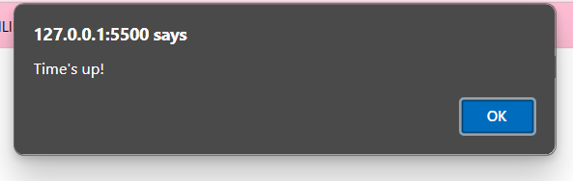

***Experiment 2.3.3: A program to reverse the string  and check if it is palindrome***

**Code:**

<!DOCTYPE html>

<html lang="en">

<head>

    <meta charset="UTF-8">

    <meta name="viewport" content="width=device-width, initial-scale=1.0">

    <title>Document</title>

    <script>

        function reverseString(str) {

        let rev="";

        for (let i=str.length-1; i>=0; i--) {

         rev+=str[i];

        }

        return rev;

        }

        function isPalindrome(str) {

        let reversed = reverseString(str);

        return str === reversed;

        }

        function processString() {

        let inputStr = document.getElementById("inputString").value;

        let charToFind = document.getElementById("charToFind").value;

        document.getElementById("reversedString").innerText = "Reversed String: " + reverseString(inputStr);

        if (isPalindrome(inputStr)) {

        document.getElementById("palindromeCheck").innerText = "The string is a palindrome.";

        } else {

          document.getElementById("palindromeCheck").innerText = "The string is NOT a palindrome.";

        }

        }

    </script>

</head>

<body>

    <h2>String Operations</h2>

    <label for="inputString">Enter a String:</label>

    <input type="text" id="inputString" placeholder="Type a string here">

    <br>

    <br>

    <button onclick="processString()">Check</button>

    <h3>Results:</h3>

    <p id="reversedString"></p>

    <p id="palindromeCheck"></p>

</body>

</html>

**Output:**

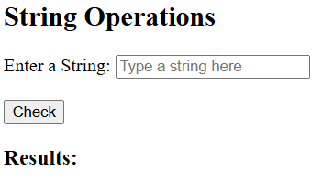

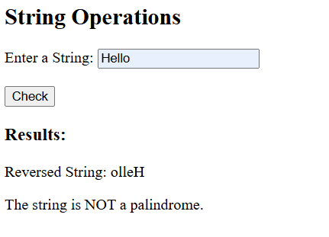

***Experiment 2.3.4: A program to find number of occurrences of character in the string***

**Code:**

<!DOCTYPE html>

  <html lang="en">

  <head>

    <meta charset="UTF-8">

    <meta name="viewport" content="width=device-width, initial-scale=1.0">

    <title>Document</title>

  </head>

  <body>

            <h2>String Operations</h2>

            <label for="inputString">Enter a String:</label>

            <input type="text" id="inputString" placeholder="Type a string here">

            <br>

            <br>

            <label for="charToFind">Character to Count:</label>

            <input type="text" id="charToFind" maxlength="1" placeholder="e.g., a">

            <br><br>

            <button onclick="processString()">Check</button>

            <h3>Results:</h3>

            <p id="charCount"></p>

    <script>

        function countCharacterOccurrences(str, char) {

        let count = 0;

        for (let i = 0; i < str.length; i++) {

        if (str[i] === char) {

            count++;

        }

        }

        return count;

        }

        function processString() {

            let inputStr = document.getElementById("inputString").value;

            let charToFind = document.getElementById("charToFind").value;

            // Character Occurrences

            if (charToFind) {

                document.getElementById("charCount").innerText = `The character '${charToFind}' appears ${countCharacterOccurrences(inputStr, charToFind)} times.`;

            } else {

                document.getElementById("charCount").innerText = "Please enter a character to count.";

            }

        }

    </script>

  </body>

  </html>

**Output:**

